Interview Grading Preparation

1. Read/ Write function
2. The read function reads the data from the device and transfers it to the user-space.
3. Writing reads the user-space data and writes it to the device.
4. Buffer saves the parameter pass in and save it as a space pointer.
5. If the returned value is less than the size parameter (the number of bytes requested), then it means that a partial transfer was made.
6. Transfer the maximum number of possible bytes between the buffer received as a parameter and the device
7. Update offset and return the length (number of bytes) of parameter.

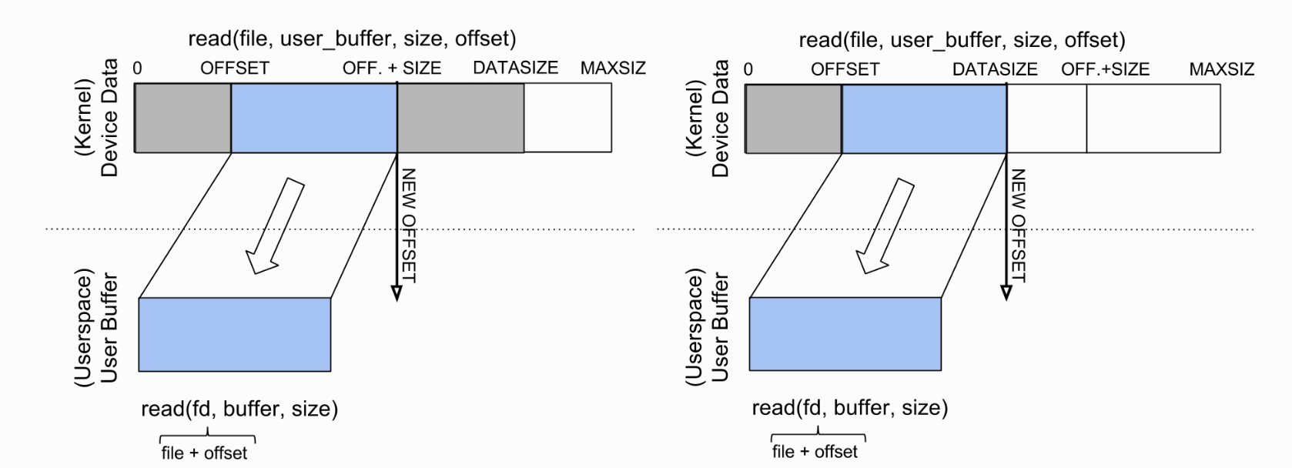

1. Seek function
2. Updating the offset value according to whence.
3. If the value of whence is 0 (SEEK_SET), the current position is set to the value of the offset.
4. If the value of whence is 1 (SEEK_CUR), the current position is incremented by offset bytes (note that offset can be negative).
5. If the value of whence is 2 (SEEK_END), the current position is set to offset bytes before the end of the file
6. Init function
7. kmalloc(size_t size, gfp_t flags) allocates memory for objects smaller than page size in the kernel. Use GFP_KERNEL for flags in this assignment.
8. void kfree(const void* kptr) frees memory previously allocated using kmalloc( ). Don’t free memory not originally allocated by kmalloc( ) or you will run into trouble.
9. register_chrdev — Register a major number for character devices.